Data Model (Structured Databases)

**PROBLEM DESCRIPTION**:

Due to the increase in customers the pet clinic wants to transfer from excel to MYSQL database. The requirement is to develop a data model using MYSQL workbench.

**BUSINESS RULES**:

1. Each customer will be given a unique ID known as CUSTOMER_ID.
2. Information on customer like email id, name, date of birth and city are saved in the CUSTOMER table.
3. PET table contains PET_ID which is unique ID given to each pet.
4. PET_SPECIES attribute in PET table shows the different species of pets that came into the clinic.
5. A customer can have multiple pets that can be brought into the clinic.
6. All pets must have a name, date of birth, weight, species and a customer ID associated with their owner.
7. Each visit must have a unique visit ID which is stored in the PET_VISIT table as VISIT_ID.
8. The information related to a visit is stored in the PET_VISIT table and information will contain date of visit, cost of visit, doctor who treated the pet and the pet ID.
9. The cost field must contain only a positive decimal value.
10. Each visit can have multiple payments corresponding to it. The information regarding payments are stored in the PAYMENTS table.
11. Every payment made will have a unique ID associated with it known as PAYMENTS_ID.
12. All payments must have a date, amount, type and visit ID.
13. The payments type attribute must only accept value of ‘cash’, ‘credit’ or ‘check’.
14. Payment amount field must only contain positive decimal values.
15. Every pet can have multiple procedures and information regarding procedures are saved in the PROCEDURE table.
16. Each procedure is assigned a unique ID known as PROCEDURE_ID.
17. Every procedure must contain cost , type, description of procedure, history of procedures on pet and requirements for the procedure.
18. Information on doctors must be saved in the DOCTORS table.
19. All doctors have a unique ID stored as DOCTOR_ID.
20. Every doctor can give multiple prescriptions and each prescription has a unique ID known as PRESCRIPTION_ID.
21. Each prescription should contain drugname, dosage , doctor id and cost where cost must be positive decimal number.
22. No field in the database must allow NULL values.

**CONCEPTUAL DESIGN AS PER CHEN’S MODEL:**

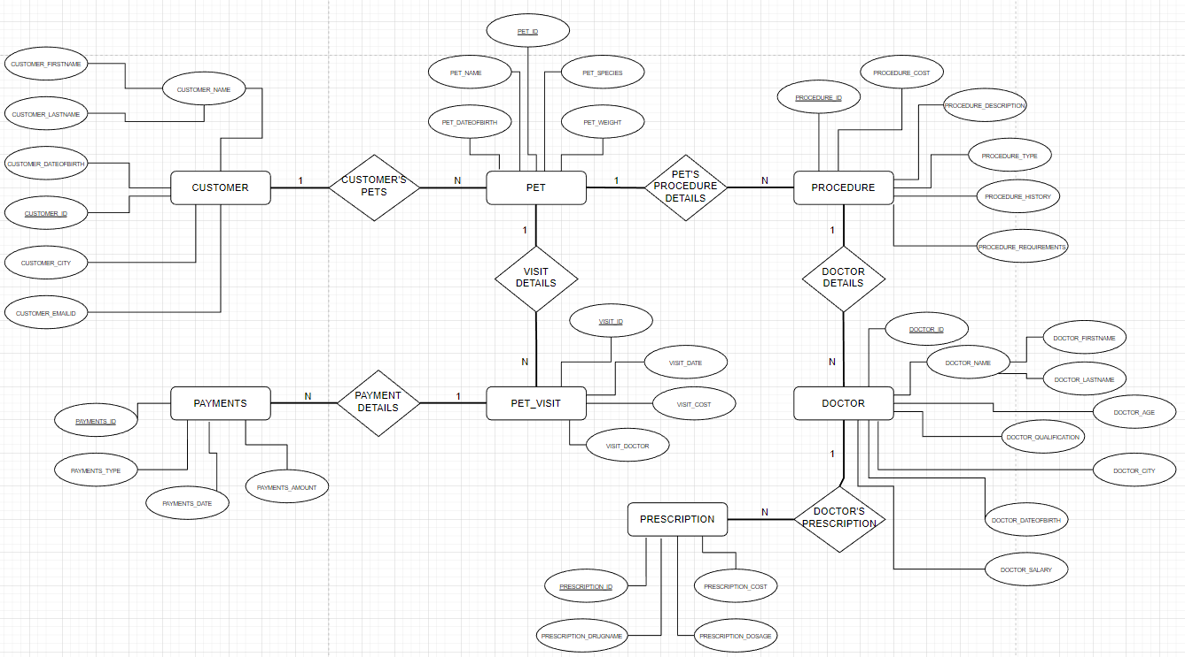

**LOGICAL MODEL - ERD DIAGRAM:**

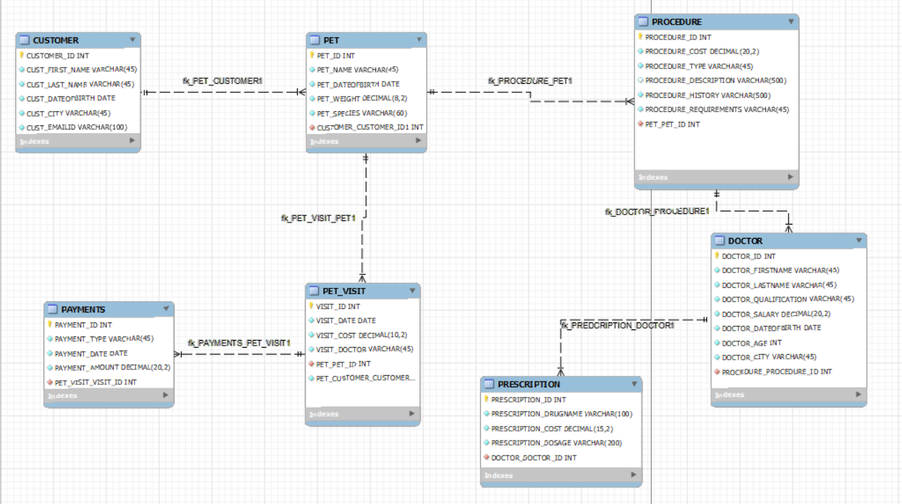

**PHYSICAL MODEL SCRIPT DEVELOPED FOR MYSQL:**

-- MySQL Workbench Forward Engineering

SET @OLD_UNIQUE_CHECKS=@@UNIQUE_CHECKS, UNIQUE_CHECKS=0;

SET @OLD_FOREIGN_KEY_CHECKS=@@FOREIGN_KEY_CHECKS, FOREIGN_KEY_CHECKS=0;

SET @OLD_SQL_MODE=@@SQL_MODE, SQL_MODE='ONLY_FULL_GROUP_BY,STRICT_TRANS_TABLES,NO_ZERO_IN_DATE,NO_ZERO_DATE,ERROR_FOR_DIVISION_BY_ZERO,NO_ENGINE_SUBSTITUTION';

-- -----------------------------------------------------

-- Schema mydb

-- -----------------------------------------------------

-- -----------------------------------------------------

-- Schema Shrey_DataModel

-- -----------------------------------------------------

-- -----------------------------------------------------

-- Schema Shrey_DataModel

-- -----------------------------------------------------

CREATE SCHEMA IF NOT EXISTS `Shrey_DataModel` ;

USE `Shrey_DataModel` ;

-- -----------------------------------------------------

-- Table `Shrey_DataModel`.`CUSTOMER`

-- -----------------------------------------------------

CREATE TABLE IF NOT EXISTS `Shrey_DataModel`.`CUSTOMER` (

`CUSTOMER_ID` INT NOT NULL,

`CUST_FIRST_NAME` VARCHAR(45) NOT NULL,

`CUST_LAST_NAME` VARCHAR(45) NOT NULL,

`CUST_DATEOFBIRTH` DATE NOT NULL,

`CUST_CITY` VARCHAR(45) NOT NULL,

`CUST_EMAILID` VARCHAR(100) NOT NULL,

PRIMARY KEY (`CUSTOMER_ID`))

ENGINE = InnoDB;

-- -----------------------------------------------------

-- Table `Shrey_DataModel`.`PET`

-- -----------------------------------------------------

CREATE TABLE IF NOT EXISTS `Shrey_DataModel`.`PET` (

`PET_ID` INT NOT NULL,

`PET_NAME` VARCHAR(45) NOT NULL,

`PET_DATEOFBIRTH` DATE NOT NULL,

`PET_WEIGHT` DECIMAL(8,2) NOT NULL,

`PET_SPECIES` VARCHAR(60) NOT NULL,

`CUSTOMER_CUSTOMER_ID1` INT NOT NULL,

PRIMARY KEY (`PET_ID`),

INDEX `fk_PET_CUSTOMER1_idx` (`CUSTOMER_CUSTOMER_ID1` ASC) VISIBLE,

CONSTRAINT `fk_PET_CUSTOMER1`

FOREIGN KEY (`CUSTOMER_CUSTOMER_ID1`)

REFERENCES `Shrey_DataModel`.`CUSTOMER` (`CUSTOMER_ID`)

ON DELETE NO ACTION

ON UPDATE NO ACTION)

ENGINE = InnoDB;

-- -----------------------------------------------------

-- Table `Shrey_DataModel`.`PET_VISIT`

-- -----------------------------------------------------

CREATE TABLE IF NOT EXISTS `Shrey_DataModel`.`PET_VISIT` (

`VISIT_ID` INT NOT NULL,

`VISIT_DATE` DATE NOT NULL,

`VISIT_COST` DECIMAL(10,2) NOT NULL,

`VISIT_DOCTOR` VARCHAR(45) NOT NULL,

`PET_PET_ID` INT NOT NULL,

`PET_CUSTOMER_CUSTOMER_ID` INT NOT NULL,

PRIMARY KEY (`VISIT_ID`),

INDEX `fk_PET_VISIT_PET1_idx` (`PET_PET_ID` ASC, `PET_CUSTOMER_CUSTOMER_ID` ASC) VISIBLE,

CONSTRAINT `fk_PET_VISIT_PET1`

FOREIGN KEY (`PET_PET_ID`)

REFERENCES `Shrey_DataModel`.`PET` (`PET_ID`)

ON DELETE NO ACTION

ON UPDATE NO ACTION)

ENGINE = InnoDB;

-- -----------------------------------------------------

-- Table `Shrey_DataModel`.`PAYMENTS`

-- -----------------------------------------------------

CREATE TABLE IF NOT EXISTS `Shrey_DataModel`.`PAYMENTS` (

`PAYMENT_ID` INT NOT NULL,

`PAYMENT_TYPE` VARCHAR(45) NOT NULL,

`PAYMENT_DATE` DATE NOT NULL,

`PAYMENT_AMOUNT` DECIMAL(20,2) NOT NULL,

`PET_VISIT_VISIT_ID` INT NOT NULL,

PRIMARY KEY (`PAYMENT_ID`),

INDEX `fk_PAYMENTS_PET_VISIT1_idx` (`PET_VISIT_VISIT_ID` ASC) VISIBLE,

CONSTRAINT `fk_PAYMENTS_PET_VISIT1`

FOREIGN KEY (`PET_VISIT_VISIT_ID`)

REFERENCES `Shrey_DataModel`.`PET_VISIT` (`VISIT_ID`)

ON DELETE NO ACTION

ON UPDATE NO ACTION)

ENGINE = InnoDB;

-- -----------------------------------------------------

-- Table `Shrey_DataModel`.`PROCEDURE`

-- -----------------------------------------------------

CREATE TABLE IF NOT EXISTS `Shrey_DataModel`.`PROCEDURE` (

`PROCEDURE_ID` INT NOT NULL,

`PROCEDURE_COST` DECIMAL(20,2) NOT NULL,

`PROCEDURE_TYPE` VARCHAR(45) NOT NULL,

`PROCEDURE_DESCRIPTION` VARCHAR(500) NULL,

`PROCEDURE_HISTORY` VARCHAR(500) NOT NULL,

`PROCEDURE_REQUIREMENTS` VARCHAR(45) NOT NULL,

`PET_PET_ID` INT NOT NULL,

PRIMARY KEY (`PROCEDURE_ID`),

INDEX `fk_PROCEDURE_PET1_idx` (`PET_PET_ID` ASC) VISIBLE,

CONSTRAINT `fk_PROCEDURE_PET1`

FOREIGN KEY (`PET_PET_ID`)

REFERENCES `Shrey_DataModel`.`PET` (`PET_ID`)

ON DELETE NO ACTION

ON UPDATE NO ACTION)

ENGINE = InnoDB;

-- -----------------------------------------------------

-- Table `Shrey_DataModel`.`DOCTOR`

-- -----------------------------------------------------

CREATE TABLE IF NOT EXISTS `Shrey_DataModel`.`DOCTOR` (

`DOCTOR_ID` INT NOT NULL,

`DOCTOR_FIRSTNAME` VARCHAR(45) NOT NULL,

`DOCTOR_LASTNAME` VARCHAR(45) NOT NULL,

`DOCTOR_QUALIFICATION` VARCHAR(45) NOT NULL,

`DOCTOR_SALARY` DECIMAL(20,2) NOT NULL,

`DOCTOR_DATEOFBIRTH` DATE NOT NULL,

`DOCTOR_AGE` INT NOT NULL,

`DOCTOR_CITY` VARCHAR(45) NOT NULL,

`PROCEDURE_PROCEDURE_ID` INT NOT NULL,

PRIMARY KEY (`DOCTOR_ID`),

INDEX `fk_DOCTOR_PROCEDURE1_idx` (`PROCEDURE_PROCEDURE_ID` ASC) VISIBLE,

CONSTRAINT `fk_DOCTOR_PROCEDURE1`

FOREIGN KEY (`PROCEDURE_PROCEDURE_ID`)

REFERENCES `Shrey_DataModel`.`PROCEDURE` (`PROCEDURE_ID`)

ON DELETE NO ACTION

ON UPDATE NO ACTION)

ENGINE = InnoDB;

-- -----------------------------------------------------

-- Table `Shrey_DataModel`.`PRESCRIPTION`

-- -----------------------------------------------------

CREATE TABLE IF NOT EXISTS `Shrey_DataModel`.`PRESCRIPTION` (

`PRESCRIPTION_ID` INT NOT NULL,

`PRESCRIPTION_DRUGNAME` VARCHAR(100) NOT NULL,

`PRESCRIPTION_COST` DECIMAL(15,2) NOT NULL,

`PRESCRIPTION_DOSAGE` VARCHAR(200) NOT NULL,

`DOCTOR_DOCTOR_ID` INT NOT NULL,

PRIMARY KEY (`PRESCRIPTION_ID`),

INDEX `fk_PREDCRIPTION_DOCTOR1_idx` (`DOCTOR_DOCTOR_ID` ASC) VISIBLE,

CONSTRAINT `fk_PREDCRIPTION_DOCTOR1`

FOREIGN KEY (`DOCTOR_DOCTOR_ID`)

REFERENCES `Shrey_DataModel`.`DOCTOR` (`DOCTOR_ID`)

ON DELETE NO ACTION

ON UPDATE NO ACTION)

ENGINE = InnoDB;

SET SQL_MODE=@OLD_SQL_MODE;

SET FOREIGN_KEY_CHECKS=@OLD_FOREIGN_KEY_CHECKS;

SET UNIQUE_CHECKS=@OLD_UNIQUE_CHECKS;